ECON 422: Econometrics 2 - Machine Learning and Economics

1. Introduction

Research Project:

Using Machine Learning to analyze cryptocurrency trends:

Can we predict Tether’s market cap evolution using other cryptocurrencies’s demand ?

Context:

Cryptocurrencies are very volatile assets, but one, the Tether, has a guaranteed exchange rate of 1 dollar per unit, making it one of the most exchanged of all since it becomes possible to exchange instantly a speculative asset against a very stable one whose value is guaranteed in dollars. Knowing this, we can expect this asset’s market cap to be positively correlated to pessimism on markets. Analyzing demand and price of the most exchanged cryptocurrencies may tell us how the Tether’s market cap will evolve.

1. Data

We are using cryptocurrencies, if we put aside their speculative value, many of them have different use, which means their demand can go up or down for different reasons:

* Bitcoin (BTC) is the most widely accepted cryptocurrency for commercial transactions online
* Ripple (XRP) is used by many banks as a tool for real-time gross settlement and remittance
* Ethereum (ETH) is a more complex system with a virtual machine that allows to execute smart contracts
* Litecoin (LTC) is very similar to bitcoin but confirms transactions must faster than bitcoin because of a different system of encryption
* Monero (XMR) provides an extra layer of privacy by making impossible for outside observers to tell the source, the amount or the destination of a transaction
* Dogecoin (DOGE) was initially created as a joke but took off and at its peak its market cap was 2 billion dollars. Unlike most cryptocurrencies, the dogecoin has no limit to the amount of coins that car be ‘mined’ or emitted, which makes it inflationary on the long term.

We will be using the data from the

1. Method

We are using .csv files such as the following to obtain the history of price, market cap and volume of transaction of the biggest cryptocurrencies.

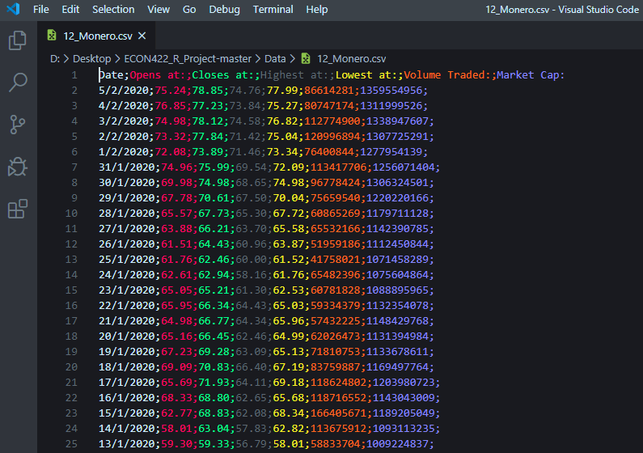

Using this data, we can see the evolution of a cryptocurrency’s value and demand. We will use these data for the 30 biggest cryptocurrencies to see

Using these data, we are able to tell if demand for one goes up, down or stay constant. Among these we know that one, the Tether has an exchange rate guaranteed of 1 USDT = 1 USD, which makes it a safe haven

1. Preliminary Results
2. Annex

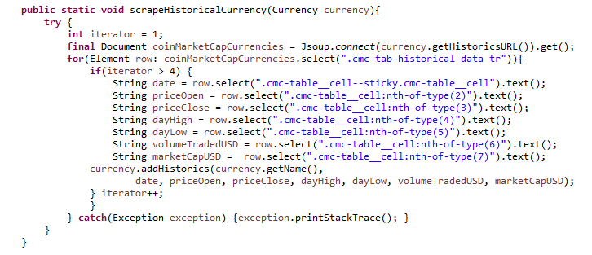Here are the most important parts of the code that we used to get the data for this part.

This method was used to identify data on a website’s page and make a java object out of it through the Currency Class.

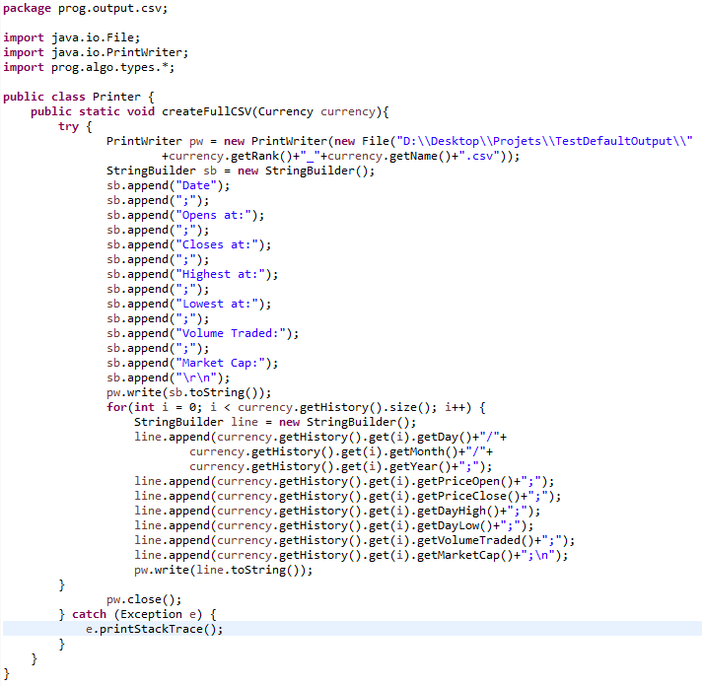

This method was used to make a CSV for every currency we had data on. For parsing reasons we used semicolons because commas were used for decimals on the site.